Catedra de Chirurgie oro-maxilo-facialăpediatrică și pedodonție „Ion Lupan” împreună cu Catedra de Chirurgie, ortopedieși anesteziologie „Natalia Gheorghiu” în cadrul proiectului „Chirurgia modernă personalizată în diagnosticulși tratamentul complex al tumorilor la copii” cu cifrul 20.80009.8007.06 –conducător prof. univ. Gh. Țîbîrnă, organizează Conferința națională științifico-practică cu participare internațională „Medicina personalizată în diagnosticul și tratamentul complex altumorilor la copii” care va avea loc la data de 23-24 aprilie 2021. Conferința are ca scop de a face o evaluare a activității proiectului pe parcursul anului 2020 și rezultatele examinării problemelor oncologiei pediatrice înRepublica Moldova.

Ion Lupan Department of Oral and Maxillofacial Pediatric Surgery and Pedodontics together with the Natalia Gheorghiu Department of Surgery, Orthopedics and Anesthesiology within the project „Modern personalized surgery in the diagnosis and complex treatment of tumors in children” with the number 20.80009.8007.06 - leader .prof. Gh. Tibirnă, organizes the National Scientific-Practical Conference with international participation „Personalized medicine in the diagnosis and complex treatment of tumors in children” which will take place on April 23-24, 2021. The conference aims to evaluate the project activity during 2020 and the results of the examination of pediatric oncology problems in the Republic of Moldova.

Invitați / Guests

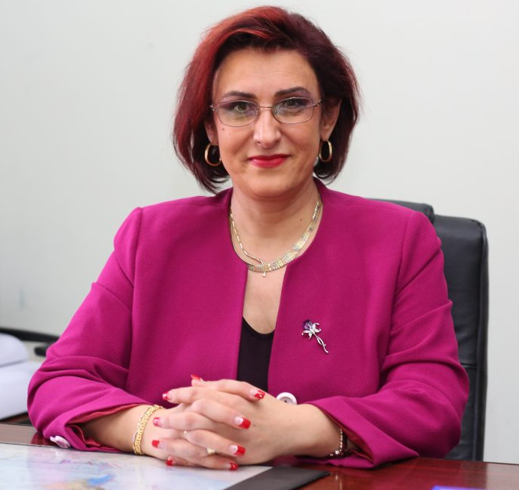
Norina Consuela Forna – dr., prof. univ., șef Departament Implantologie, Protetică Dentara – UMF „Grigore T. Popa”, Iași, România
Forna Consuela Norina – PhD, univ. Professor, head of the Department of Implantology, Dental Prosthetics – Grigore T. Popa UMF, Iasi, Romania

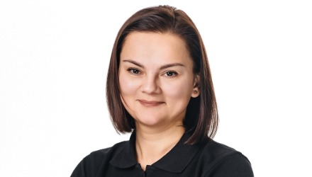

Годованець Оксана
Доктор медичних наук, профессор,
Завідувач кафедри стоматології дитячого віку — «БУКОВИНСЬКИЙ ДЕРЖАВНИЙ МЕДИЧНИЙ УНІВЕРСИТЕТ» Медичний консультативний центр
Godovanets Oksana
Doctor of Medical Sciences, Professor, Head of the Department of Dentistry for Children - "BUKOVINSKY STATE MEDICAL UNIVERSITY" Medical Advisory Center

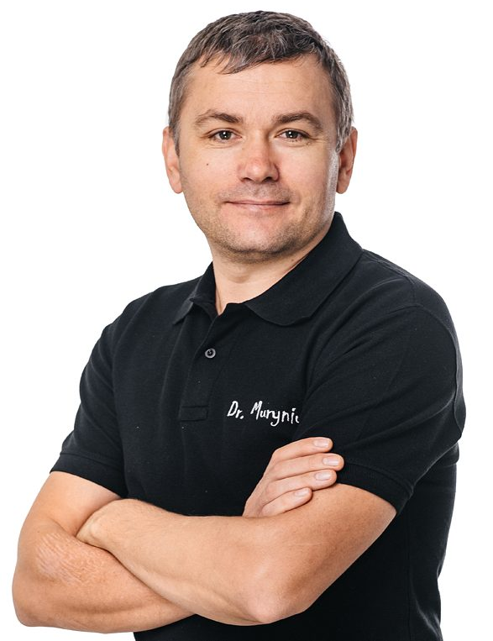
Муринюк Тарас
Асистент кафедри стоматології дитячого віку — «БУКОВИНСЬКИЙ ДЕРЖАВНИЙ МЕДИЧНИЙ УНІВЕРСИТЕТ» Медичний консультативний центр
Murinyuk Taras
Assistant of the Department of Dentistry of a Child Viku - "BUKOVINSKY STATE MEDICAL UNIVERSITY" Medical Advisory Center

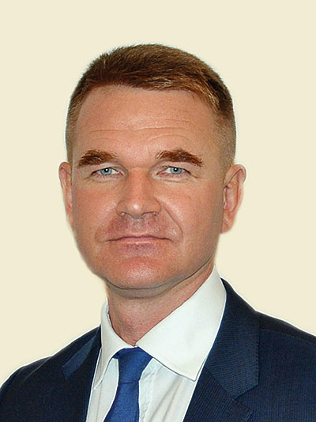
Постников Михаил
Д.м.н., доцент кафедры стоматологии ИПО СамГМУ, врач-ортодонт высшей категории, директора «Многопрофильной клиники Постникова», Самара
Postnikov Mikhail
Doctor of Medical Sciences, Associate Professor of the Department of Dentistry IPO SamSMU, orthodontist of the highest category, Director of the Postnikov Multidisciplinary Clinic, Samara

Рубникович Сергей Петрович
Доктор медицинских наук, доцент. Заведующий кафедрой ортопедической стоматологии ГУО «Белорусская медицинская академия последипломного образования», Минск, Белоруссия
Rubnikovich Sergei Petrovich
Doctor of Medical Sciences, Associate Professor. Head of the Department of Prosthetic Dentistry, State Educational Institution "Belarusian Medical Academy of Postgraduate Education", Minsk, Belarus
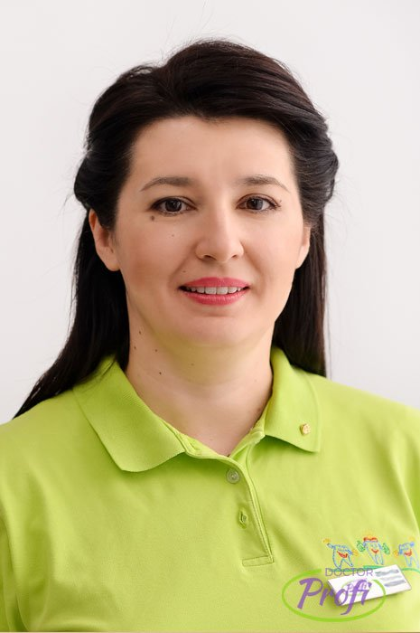
Денисова Юлия Леонидовна
Профессор, доктор медицинских наук, заведующий кафедры 3-ей терапевтической стоматологии БГМУ, д.м.н., профессор, Минск, Белоруссия
Denisova Yulia Leonidovna
Professor, Doctor of Medical Sciences, Head of the Department of 3rd Therapeutic Dentistry, Belarusian State Medical University, Doctor of Medical Sciences, Professor, Minsk, Belarus
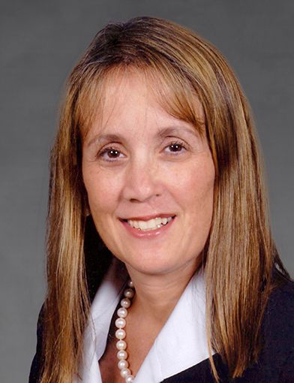
Lisa Renee David, MD, MBA
Professor and Chairman, Louis C. Argenta Endowed Chair of Plastic and Reconstructive Surgery, Wake Forest School of Medicine, Winston-Salem, USA
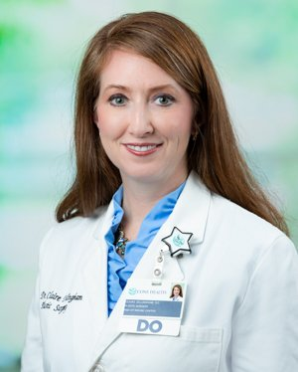
Claire Sanger Dillingham, DO,
Doctor of Osteopathic Medicine, Plastic/Reconstructive Surgery, CHMG’s chief of plastic surgery. Wake Forest University, USA

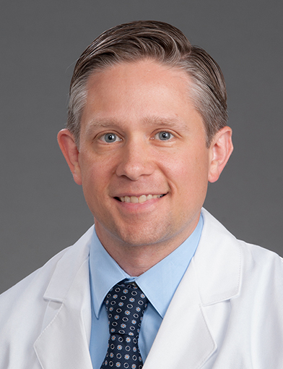
Christopher Runyan, MD, PhD, Assistant Professor for the department of Plastic and Reconstructive Surgery at Wake Forest Baptist Health

